AR7091G Industrial Edge Computing Gateway User Manual
Water conservancy Video RTU/ Power Communication Management
Machine/Edge Computing Gateway /CPE

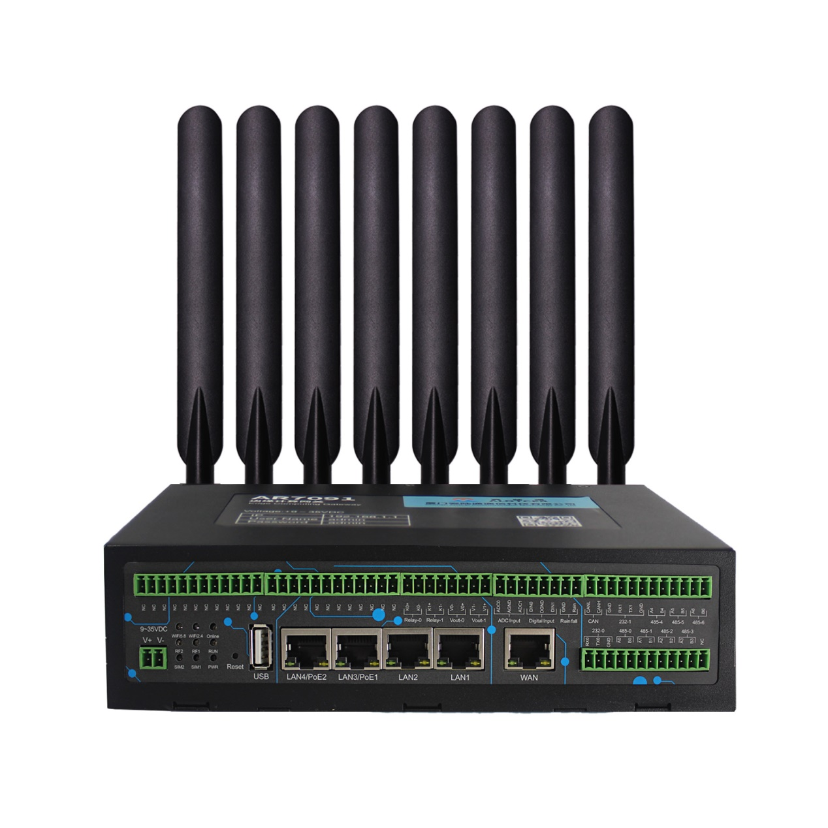

Xiamen Alotcer Communication Technology Co., Ltd.
Tel:+86-18106932752
Fax:+86 592-6195620
Web: https://www.alotceriot.com/
E-mail:anne@alotcer.com
Add: Room 502, No.146 Xinglinbei 2nd Road, Jimei District, Xiamen, China, 361022

Applicable Models
Product Type | Model | Product Name
Standard | AR7091G-RS | 5G Dual SIM Industrial Edge Computing Gateway
Standard | AR7091G-LS | 5G Redcap Dual SIM Industrial Edge Computing Gateway
Standard | AR7091G-FS | 4G FDD Dual SIM Industrial Edge Computing Gateway
Standard | AR7091G-QS | 4G FDD/TDD Dual SIM Industrial Edge Computing Gateway
Standard | AR7091G-HS | 4G Cat1 Dual SIM Industrial Edge Computing Gateway
Standard+ GPS | AR7091G-RSP | GPS+5G Dual SIM Industrial Edge Computing Gateway
Standard+ GPS | AR7091G-LSP | GPS+5G Redcap Dual SIM Industrial Edge Computing Gateway
Standard+ GPS | AR7091G-FSP | GPS+4G FDD Dual SIM Industrial Edge Computing Gateway
Standard+ GPS | AR7091G-QSP | GPS+4G FDD/TDD Dual SIM Industrial Edge Computing Gateway
Standard+ GPS | AR7091G-HSP | GPS+4G Cat1 Dual SIM Industrial Edge Computing Gateway
Standard+ Dual Module | AR7091GS-RR | 5G Dual Module Industrial Edge Computing Gateway
Standard+ Dual Module | AR7091GS-RF | 5G&4G Dual Module Industrial Edge Computing Gateway
Standard+ Dual Module | AR7091GS-LL | 5G Redcap Dual Module Industrial Edge Computing Gateway
Standard+ Dual Module | AR7091GS-FF | 4G FDD Dual Module Industrial Edge Computing Gateway
Standard+ Dual Module | AR7091GS-HH | 4G Cat1 Dual Module Industrial Edge Computing Gateway
Standard+ Dual Module | AR7091GS-HH | 4G Cat1 Dual Module Industrial Edge Computing Gateway
Standard+ GPS+  Dual Module | AR7091GS-RRP | GPS+5G Dual Module Industrial Edge Computing Gateway
Standard+ GPS+  Dual Module | AR7091GS-RFP | GPS+5G&4G Dual Module Industrial Edge Computing Gateway
Standard+ GPS+  Dual Module | AR7091GS-LLP | GPS+5G Redcap Dual Module Industrial Edge Computing Gateway
Standard+ GPS+  Dual Module | AR7091GS-FFP | GPS+4G FDD Dual Module Industrial Edge Computing Gateway
Standard+ GPS+  Dual Module | AR7091GS-QQP | GPS+4G FDD/TDD Dual Module Industrial Edge Computing Gateway
Standard+ GPS+  Dual Module | AR7091GS-HHP | GPS+4G Cat1 Dual Module Industrial Edge Computing Gateway
Enhanced | AR7091GK-RS | 5G Dual SIM Enhanced Industrial Edge Computing Gateway
Enhanced | AR7091GK-LS | 5G Redcap Dual SIM Enhanced Industrial Edge Computing Gateway
Enhanced | AR7091GK-FS | 4G FDD Dual SIM Enhanced Industrial Edge Computing Gateway
Enhanced | AR7091GK-QS | 4G FDD/TDD Dual SIM Enhanced Industrial Edge Computing Gateway
Enhanced | AR7091GK-HS | 4G Cat1 Dual SIM Enhanced Industrial Edge Computing Gateway
Enhanced+  GPS | AR7091GK-RSP | GPS+5G Dual SIM Enhanced Industrial Edge Computing Gateway
Enhanced+  GPS | AR7091GK-LSP | GPS+5G Redcap Dual SIM Enhanced Industrial Edge Computing Gateway
Enhanced+  GPS | AR7091GK-FSP | GPS+4G FDD Dual SIM Enhanced Industrial Edge Computing Gateway
Enhanced+  GPS | AR7091GK-QSP | GPS+4G FDD/TDD Dual SIM Enhanced Industrial Edge Computing Gateway
Enhanced+  GPS | AR7091GK-HSP | GPS+4G Cat1 Dual SIM Enhanced Industrial Edge Computing Gateway
Enhanced+ Dual Module | AR7091GKS-RR | 5G Dual Module Enhanced Industrial Edge Computing Gateway
Enhanced+ Dual Module | AR7091GKS-RF | 5G&4G Dual Module Enhanced Industrial Edge Computing Gateway
Enhanced+ Dual Module | AR7091GKS-LL | 5G Redcap Dual Module Enhanced Industrial Edge Computing Gateway
Enhanced+ Dual Module | AR7091GKS-FF | 4G FDD Dual Module Enhanced Industrial Edge Computing Gateway
Enhanced+ Dual Module | AR7091GKS-QQ | 4G FDD/TDD Dual Module Enhanced Industrial Edge Computing Gateway
Enhanced+ Dual Module | AR7091GKS-HH | 4G Cat1 Dual Module Enhanced Industrial Edge Computing Gateway
Enhanced+ GPS+  Dual Module | AR7091GKS-RRP | GPS+5G Dual Module Enhanced Industrial Edge Computing Gateway
Enhanced+ GPS+  Dual Module | AR7091GKS-RFP | GPS+5G&4G Dual Module Enhanced Industrial Edge Computing Gateway
Enhanced+ GPS+  Dual Module | AR7091GKS-LLP | GPS+5G Redcap Dual Module Enhanced Industrial Edge Computing Gateway
Enhanced+ GPS+  Dual Module | AR7091GKS-FFP | GPS+4G FDD Dual Module Enhanced Industrial Edge Computing Gateway
Enhanced+ GPS+  Dual Module | AR7091GKS-QQP | GPS+4G FDD/TDD Dual Module Enhanced Industrial Edge Computing Gateway
Enhanced+ GPS+  Dual Module | AR7091GKS-HHP | GPS+4G Cat1 Dual Module Enhanced Industrial Edge Computing Gateway

Version
Version | Author | Check | Date | Description
V1.0 | Lanw | Deron | 2023-3-13 | Initial
V1.1 | Lanw | Deron | 2023-6-6 | 1,Update product models
V1.2 | Deron |  | 2024-7-26 | 2,Add 5G Redcap models
V1.3 | Deron |  | 2024-10-23 | 1,Add North&South End protocol
V1.4 | Deron |  | 2025-4-8 | 1,Add North protocol:ModbusRTU/TCP  2,Update the “Function Extension 2” description.

Contents
Applicable Models 2
Version 4
Contents 5
Chapter 1 Brief Introduction 6
1.1 General 6
1.2 Product Feature 6
1.3 Block Diagram 9
1.4 Product SPEC 9
1.5 Ordering Information 12
Chapter 2 Installation Introduction 14
2.1 General 14
2.2 Packing List 14
2.3 User Interface Description 14
2.4 Installation and Cable Connection 17
2.5 Power 22
2.6 LED 23
2.7 Reset Button Introduction 23
2.8 Installation Introduction 24
2.9 Lightning protection Introduction 24

Brief Introduction

General
AR7091G is an industrial Internet of Things edge computing gateway /CPE/ water conservancy video RTU/ power communication management machine developed based on 5G/4G/3G/2G, WiFi, VPN technologies. The product adopts high-performance industrial 32-bit processor, with embedded operating system. It supports 1 Gigabit Ethernet WAN/1 Gigabit SFP optical port (optional), 4 Gigabit Ethernet LAN ports (PoE is optional for 2), 1 RS232 (2 for enhanced model), 4 isolated RS485 (7 for enhanced model), 1 USB2.0, 1 Micro SD card, 1 rainfall collection, 1 AI, 2 DI, 2 relay, 2 controllable power supplies, 1 CAN bus, 2.4G/5.8G WiFi interface that can conveniently connect one device to a cellular network. It can be connected to serial device, Ethernet device and WiFi device at the same time.

It has been widely used on M2M fields, such as intelligent transportation, smart grid, postal services, industrial automation, telemetry, finance, POS, water supply, environment protection, post, weather, and so on.

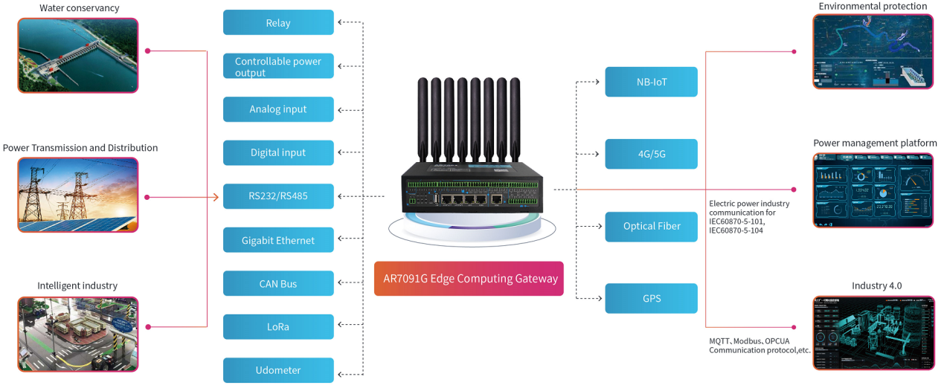
Application Topology

Product Feature
Items | Contents
Industrial Design | High-powered industrial cellular module
Industrial Design | High-powered industrial 32-bit CPU
Industrial Design | Housing: iron, providing IP30 protection.
Industrial Design | Power range: DC 9~35V
High Reliability | Support hardware and software WDT
High Reliability | Support auto recovery mechanism to make router always online
High Reliability | Ethernet port: 1.5KV magnetic isolation protection
High Reliability | RS232/RS485 port: 15KV ESD protection
High Reliability | SIM/UIM port: 15KV ESD protection
High Reliability | Power port: reverse-voltage and over voltage protection
High Reliability | Antenna port: lightning protection(optional)
Standard and Convenience | Support standard RS232(or RS485/RS422), Ethernet and WiFi port that can connect to serial, Ethernet and WiFi devices directly
Standard and Convenience | Support standard WAN port and PPPOE protocol that can connect to ADSL directly
Standard and Convenience | Support intellectual mode, enter into communication state automatically when powered
Standard and Convenience | Support several work modes
Standard and Convenience | Convenient configuration and maintenance interface（WEB or CLI）
High-performance and Security | Support multiple WAN access methods, including static IP, DHCP, PPPOE, 2.5G/3G/4G/5G.
High-performance and Security | Support double link backup between 2.5G/3G/4G/5G and WAN (optional).
High-performance and Security | Support VPN (PPTP, L2TP, IPSEC, Openvpn and GRE (TAP))
High-performance and Security | Support remote management, SYSLOG, SNMP, TELNET, SSH, HTTPS, etc.
High-performance and Security | Support local and remote firmware upgrade, import and export configure file.
High-performance and Security | Support NTP, RTC embedded.
High-performance and Security | Support multiple DDNS provider service.
High-performance and Security | Support MAC address cloning.
High-performance and Security | WiFi support 802.11b/g/n/ac. support AP, client.
High-performance and Security | WiFi support 802.11ax (optional)
High-performance and Security | WiFi support WEP, WPA, WPA2 encryption.
High-performance and Security | Support multiple online trigger ways, including SMS, ring and data. Support link disconnection when timeout.
High-performance and Security | Support APN/VPDN.
High-performance and Security | Support VRRP link backup
High-performance and Security | Support multiple DHCP server and DHCP client, DHCP binding MAC address, DDNS, Firewall, NAT, DMZ host, QoS, traffic statistics, real-time display data transfer rate etc.
High-performance and Security | Support IoT protocol MQTT client and server (support CA)
High-performance and Security | Support industrial control OPCUA protocol and MODBUS protocol conversion
High-performance and Security | Support Python secondary development platform (Python3)
High-performance and Security | Support TCP/IP, UDP, FTP(optional), HTTP, etc.
High-performance and Security | Supports SPI firewall, VPN pass-through, access control, URL filtering,etc.
High-performance and Security | Support local log storage.
High-performance and Security | Support GPS(optional).
High-performance and Security | Support dual 4G/5G module (optional)
High-performance and Security | Support PoE (optional)
High-performance and Security | Support SFP (optional)
High-performance and Security | Support online network testing
High-performance and Security | Support rainfall data collection (enhanced model)
High-performance and Security | Support CAN bus communication (enhanced model)
High-performance and Security | Support analog data collection (enhanced model)
High-performance and Security | Support digital data collection (enhanced model)
High-performance and Security | Support the photo capture function
High-performance and Security | Support NB-IoT, Lora, Ultrashort wave communication
High-performance and Security | The modular architecture of hardware and software
High-performance and Security | Support customization of I/O interfaces board
North End protocol - Report | MQTT (JSON)/Mobile cloud/Alibaba Cloud/Telecom cloud/Huawei Cloud
North End protocol - Report | ModbusRTU/TCP
North End protocol - Report | OPCUA (Optional)
North End protocol - Report | IEC101 (Optional)
North End protocol - Report | IEC104 (Optional)
South End Protocol - Acquisition | ModbusRTU/TCP/OverTCP
South End Protocol - Acquisition | Siemens S7-S200/S200Smart/S300/S400/S1200/S1500 (Optional)
South End Protocol - Acquisition | DLT645 (Optional)
South End Protocol - Acquisition | DNP3.0 Master (Optional)

Block Diagram
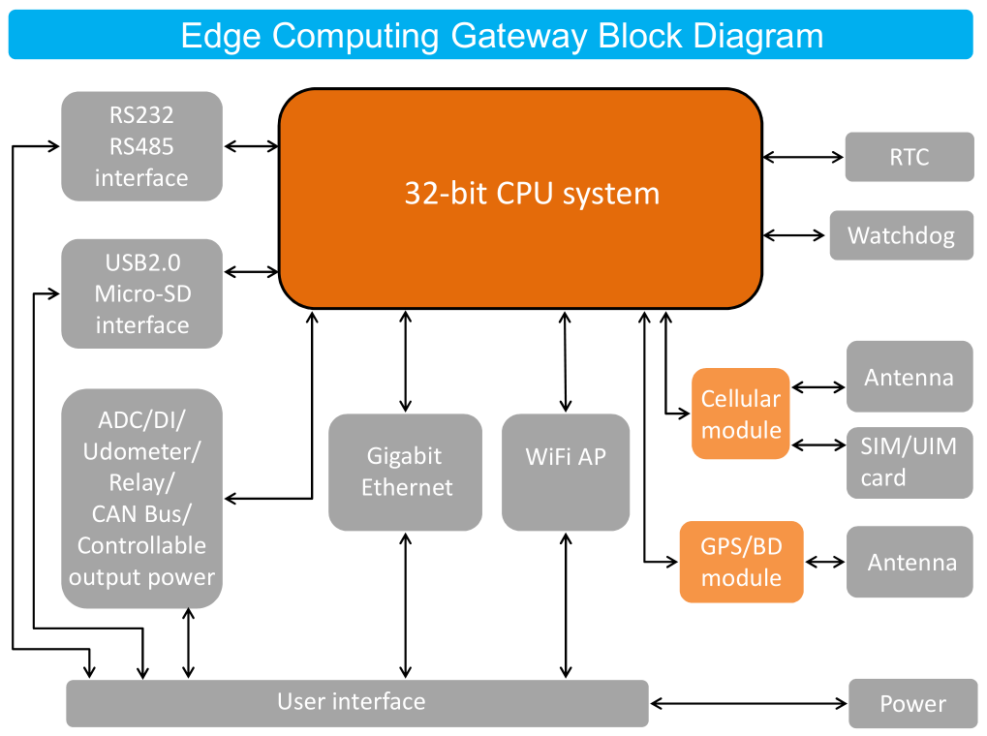

Product SPEC
Items |  | Contents
Hardware System | CPU | Industrial 32-bit CPU
Hardware System | FLASH | 16MB (Extendable to 64MB)
Hardware System | SDRAM | 512MB
Interface | WAN | 1 Gigabit WAN port(RJ45) /1 Gigabit SFP optical port (optional, the Ethernet and SFP cannot be used at the same time), auto MDI/MDIX, 1.5KV magnetic isolation protection
Interface | LAN | 4 Gigabit Ethernet ports(RJ45), auto MDI/MDIX, 1.5KV magnetic isolation protection
Interface | Serial | 1 RS232 port (Shared with RS485, 2 for enhanced model), 4 isolated RS485 port( 7 for enhanced model, the RS232-0 and RS485-0 cannot be used at the same time, the RS232-1 and RS485-4 cannot be used at the same time),15KV ESD protection  Data bits: 5, 6 ,7, 8  Stop bits: 1, 1.5(optional), 2  Parity: none, even, odd, space(optional), mark(optional)  Baud rate: 2400~115200 bps
Interface | Antenna | Cellular: Standard SMA female interface, 50 ohm  WiFi: Standard SMA male interface, 50 ohm  GPS(optional):Standard SMA female interface, 50 ohm
Interface | SIM/UIM | Standard 3V/1.8V user card interface, 15KV ESD protection
Interface | Micro SD card | Standard self-propelled Micro SD card interface (Max 128GB)
Interface | USB | Standard USB2.0 Type-A, support USB storage
Interface | Power | Standard 2-PIN 3.81mm terminal, reverse-voltage and over voltage protection
Interface | Reset | Press this key for 8 seconds to restore the module to its original factory default settings
Interface | Extended application interface (enhanced model) | 1 rainfall collection
Interface | Extended application interface (enhanced model) | 2 analog input ports, 12-bit ADC, support 4-20mA or 0-5V, accuracy: 0.5%
Interface | Extended application interface (enhanced model) | 2 optical isolation digital input ports  Logic 0: wet contact 0-3V DC, or dry contact is connected  Logic 1: wet contact 5-30V DC, or dry contact is disconnected
Interface | Extended application interface (enhanced model) | 1 CAN bus (compatible with ISO 11898 standard)
Interface | Extended application interface (enhanced model) | 2 relay interfaces  Maximum switching voltage: 30V DC/250V AC  Maximum switching current: 5A  Maximum switching power: 150W
Interface | Extended application interface (enhanced model) | 2 controllable power supplies (The output voltage is equal to the power supply voltage of the device. The default value is 12V DC. Single rated output current 1A, total rated output current 2A, built-in overcurrent protection, enhanced model)
Interface | LED | “PWR”, “RUN”, “SIM1”, “SIM2”, “Online”, “LAN1”, “LAN2”, “LAN3”, “LAN4”, “WAN”, “MOD1 Signal strength”, “MOD2 Signal strength”, “WiFi2.4”, “WiFi5.8”
Network | Wireless Network | 5G NR SA/NSA:n1/2/3/5/7/8/12/20/28/41/66/71/ 77/78/79  TDD-LTE:B38/39/40/41  FDD-LTE:B1/2/3/4/5/7/8/13/17/20/25/28  WCDMA:850/900/1900/2100MHz  TD-SCDMA:1880-1920/2010-2025MHz(A/F)  CDMA2000 1x/ EVDO Rev. A:800/1900MHz  GSM/GPRS/EDGE:850/900/1800/1900MHz  CDMA:800/1900MHz
Network | WAN | Support PPP/PPPOE
Network | LAN | Support APR
Network | Network Authentication | Support CHAP/PAP Authentication
Network | Network Access | Support APN/VPDN
Network | IP Applications | Support Ping、Trace、DHCPServer 、DHCP Relay、 DHCP Client、DNS relay、DDNS 、Telnet
Network | IP Routing | Support static routing
WiFi | Standard | IEEE802.11b/g/n, 2.4G support AP and Station mode  IEEE802.11ac, 5.8G support AP and Station mode  IEEE802.11ax, 2.4G & 5.8G (optional)
WiFi | Bandwidth | IEEE802.11b/g: 54Mbps (max)  IEEE802.11n: 300Mbps (max)  IEEE802.11ac: 866Mbps (max)  IEEE802.11ax: 1201Mbps (max)
WiFi | Security | WEP, WPA, WPA2, etc. WPS (optional)
GPS  (optional) | Receiver Type | 50-channle  GPS L1(1575.42MHz) C/A code  SBAS: WAAS,EGNOS,MSAS,GAGAN
GPS  (optional) | Max. update rate | 5 Hz
GPS  (optional) | Accuracy | Position: 2.5m CPE  SBAS: 2.0m CPE
GPS  (optional) | Location | Cold starts: 32s  Warm starts: 32s  Aided starts: <1s  Hot starts: <3s
GPS  (optional) | Sensitivity | Tracking: -160dBm  Reacquisition: -160dBm  Cold starts: -146dBm
GPS  (optional) | Timing accuracy | RMS: 30ns  99%: <60ns  Granularity: 21ns
GPS  (optional) | Time pulse | Configurable, 0.25 to 1000Hz
Power supply (standard model) | Power range | DC 9~35V (12V DC recommended)
Power supply (standard model) | Consumption1 | <660mA (@12V DC, one module 4G)
Power supply (standard model) | Consumption2 | <680mA (@12V DC, dual module 4G)
Power supply (standard model) | Max current | <1200mA (@12V DC, dual 5G)
Power supply (enhanced model) | Power range | DC 9~35V (12V DC recommended)
Power supply (enhanced model) | Consumption1 | <700mA (@12V DC, one module 4G)
Power supply (enhanced model) | Consumption2 | <740mA (@12V DC, dual module 4G)
Power supply (enhanced model) | Max current | <1200mA (@12V DC, dual 5G)
Mechanical | Dimensions | 209x150x55mm (excluding accessories)
Mechanical | Weight | 1575g (excluding accessories)
Environmental Limits | Operating Temperature | -35~+75ºC (-31~+167℉)
Environmental Limits | Storage Temperature | -40~+85ºC (-40~+185℉)
Environmental Limits | Operating Humidity | - 95% (Non-condensing)
Installation | Hanger | The fixing piece is at both sides
Installation | Rail | 35mm DIN rail

Ordering Information
Model | Version
Model | Network Abbreviation | Function Extension 1 | Function Extension 2
AR7091G  (Standard) | -R: 5G  -L: 5G Redcap  -F: 4G FDD-LTE  -Q: 4G FDD/FDD-LTE  -H: 4G Cat1  -N: Without wireless Module | S: Dual SIM Card  P: GPS | E: Encryption  F: Optical fiber  Q: PoE  B: Bluetooth  L: Lora
AR7091GS  (Standard + Dual Module) | RR: Dual 5G  LL: Dual 5G Redcap  FF: Dual 4G FDD-LTE  QQ: Dual 4G TDD/FDD-LTE  HH: Dual 4G Cat1  RF: 5G+4G | P: GPS | E: Encryption  F: Optical fiber  Q: PoE  B: Bluetooth  L: Lora
AR7091GK  (Enhanced) | -R: 5G  -L: 5G Redcap  -F: 4G FDD-LTE  -Q: 4G FDD/FDD-LTE  -H: 4G Cat1  -N: Without wireless Module | S: Dual SIM Card  P: GPS | E: Encryption  F: Optical fiber  Q: PoE  B: Bluetooth  L: Lora
AR7091GKS  (Enhanced + Dual Module) | RR: Dual 5G  LL: Dual 5G Redcap  FF: Dual 4G FDD-LTE  QQ: Dual 4G TDD/FDD-LTE  HH: Dual 4G Cat1  RF: 5G+4G | P: GPS | E: Encryption  F: Optical fiber  Q: PoE  B: Bluetooth  L: Lora
Example | 1. AR7091G-RSP：AR7091G 5G Standard Industrial Edge Computing Gateway/CPE, support GPS, Dual SIM Card.  2、AR7091GKS-RFP：AR7091GKS 5G+4G Enhanced Industrial Edge Computing Gateway/CPE, MOD 1 is 5G, MOD 2 is 4G, support GPS, Dual SIM Card, support extended application interface .

Installation Introduction

General
The edge computing gateway must be installed correctly to make it work properly.

Warning: Forbid to install the edge computing gateway when powered!

Packing List
Name | Quantity | Remark
Edge Computing Gateway host | 1
Cellular antenna (Male SMA) | 2-6
WiFi antenna (Female SMA) | 2-4
SIM card holder | 2
RJ45 network cable | 1
Certification card | 1
RS232 cable | 1
2pin 3.81mm pitch terminal (male) | 1
12pin 3.5mm pitch terminal (male) | 1-4
8pin 3.5mm pitch terminal (male) | 2 | Only enhanced model
Power adapter | 1 | Optional
Micro-SD card | 1 | Optional
RS485 cable | 1 | Optional
GPS antenna | 1 | Optional

User Interface Description

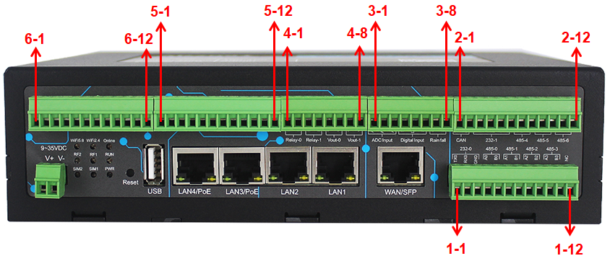
User Interface Definition Table
Number | Function | Name | Default | Remark
1-1 | 232-0 | RX0 | Channel 0 RS232 receiver (Edge Computing Gateway receiver) | The RS232-0 and RS485-0 cannot be used at the same time
1-2 | 232-0 | TX0 | Channel 0 RS232 transmitter (Edge Computing Gateway transmitter) | The RS232-0 and RS485-0 cannot be used at the same time
1-3 | 232-0 | GND | Channel 0 RS232 GND | The RS232-0 and RS485-0 cannot be used at the same time
1-4 | 485-0 | A0 | Channel 0 RS485 A | The RS232-0 and RS485-0 cannot be used at the same time
1-5 | 485-0 | B0 | Channel 0 RS485 B | The RS232-0 and RS485-0 cannot be used at the same time
1-6 | 485-1 | A1 | Channel 1 RS485 A
1-7 | 485-1 | B1 | Channel 1 RS485 B
1-8 | 485-2 | A2 | Channel 2 RS485 A
1-9 | 485-2 | B2 | Channel 2 RS485 B
1-10 | 485-3 | A3 | Channel 3 RS485 A
1-11 | 485-3 | B3 | Channel 3 RS485 B
1-12 | NA | NC | Not Connected
2-1 | CAN Bus | CANL | Low level CAN bus line | Compatible with ISO 11898 standard
2-2 | CAN Bus | CANH | High level CAN bus line | Compatible with ISO 11898 standard
2-3 | 232-1 | GND | Channel 1 RS232 GND | The RS232-1 and RS485-4 cannot be used at the same time
2-4 | 232-1 | RX1 | Channel 1 RS232 receiver (Edge Computing Gateway receiver) | The RS232-1 and RS485-4 cannot be used at the same time
2-5 | 232-1 | TX1 | Channel 1 RS232 transmitter (Edge Computing Gateway transmitter) | The RS232-1 and RS485-4 cannot be used at the same time
2-6 | 232-1 | GND | Channel 1 RS232 GND | The RS232-1 and RS485-4 cannot be used at the same time
2-7 | 485-4 | A4 | Channel 4 RS485 A | The RS232-1 and RS485-4 cannot be used at the same time
2-8 | 485-4 | B4 | Channel 4 RS485 B | The RS232-1 and RS485-4 cannot be used at the same time
2-9 | 485-5 | A4 | Channel 5 RS485 A
2-10 | 485-5 | B4 | Channel 5 RS485 B
2-11 | 485-6 | A4 | Channel 6 RS485 A
2-12 | 485-6 | B4 | Channel 6 RS485 B
3-1 | Analog Input | ADC0 | Channel 0 analog input | 12-bit ADC, support 4-20mA or 0-5V, accuracy: 0.5%
3-2 | Analog Input | AGND | Analog GND | 12-bit ADC, support 4-20mA or 0-5V, accuracy: 0.5%
3-3 | Analog Input | ADC1 | Channel 1 analog input | 12-bit ADC, support 4-20mA or 0-5V, accuracy: 0.5%
3-4 | Digital input | DIN0 | Channel 0 digital input | Optical isolation  Logic 0: wet contact 0-3V DC, or dry contact is connected  Logic 1: wet contact 5-30V DC, or dry contact is disconnected
3-5 | Digital input | DGND | Digital GND
3-6 | Digital input | DIN1 | Channel 1 digital input
3-7 | Rainfall | GND | Udometer GND | Udometer interface
3-8 | Rainfall | Rain | Udometer input | Udometer interface
4-1 | Relay-0 | K0+ | Channel 0 relay positive | Maximum switching voltage: 30V DC/250V AC  Maximum switching current: 5A  Maximum switching power: 150W
4-2 | Relay-0 | K0- | Channel 0 relay negative
4-3 | Relay-1 | K1+ | Channel 1 relay positive
4-4 | Relay-1 | K1- | Channel 1 relay negative
4-5 | Vout-0 | V0- | Channel 0 controllable power output negative | The output voltage is equal to the power supply voltage of the device  The default value is 12V DC  Single rated output current 1A
4-6 | Vout-0 | V0+ | Channel 0 controllable power output positive
4-7 | Vout-1 | V1- | Channel 1 controllable power output negative
4-8 | Vout-1 | V1+ | Channel 1 controllable power output positive
5-1 | NA | NC | Not Connected | Customizable function
5-2 | NA | NC | Not Connected | Customizable function
5-3 | NA | NC | Not Connected | Customizable function
5-4 | NA | NC | Not Connected | Customizable function
5-5 | NA | NC | Not Connected | Customizable function
5-6 | NA | NC | Not Connected | Customizable function
5-7 | NA | NC | Not Connected | Customizable function
5-8 | NA | NC | Not Connected | Customizable function
5-9 | NA | NC | Not Connected | Customizable function
5-10 | NA | NC | Not Connected | Customizable function
5-11 | NA | NC | Not Connected | Customizable function
5-12 | NA | NC | Not Connected | Customizable function
6-1 | NA | NC | Not Connected | Customizable function
6-2 | NA | NC | Not Connected | Customizable function
6-3 | NA | NC | Not Connected | Customizable function
6-4 | NA | NC | Not Connected | Customizable function
6-5 | NA | NC | Not Connected | Customizable function
6-6 | NA | NC | Not Connected | Customizable function
6-7 | NA | NC | Not Connected | Customizable function
6-8 | NA | NC | Not Connected | Customizable function
6-9 | NA | NC | Not Connected | Customizable function
6-10 | NA | NC | Not Connected | Customizable function
6-11 | NA | NC | Not Connected | Customizable function
6-12 | NA | NC | Not Connected | Customizable function

Installation and Cable Connection
Dimension (The fixing piece is detachable): (Unit: mm)
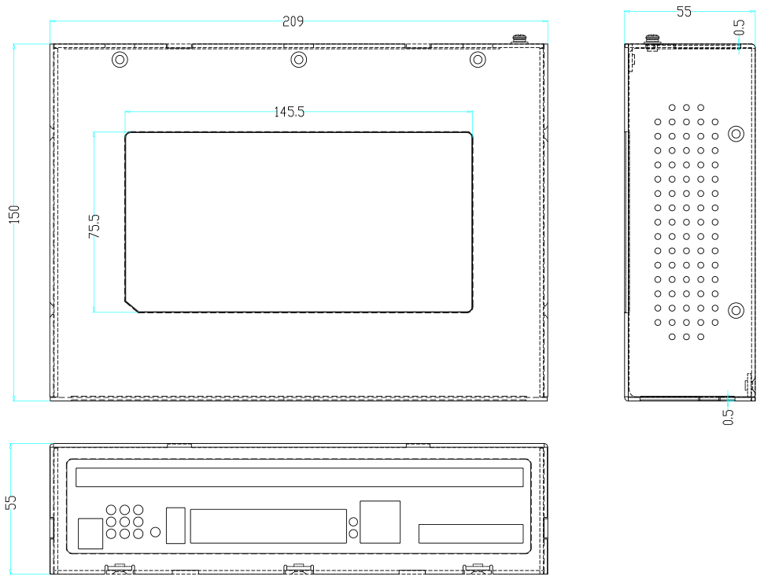

Installation of antenna:
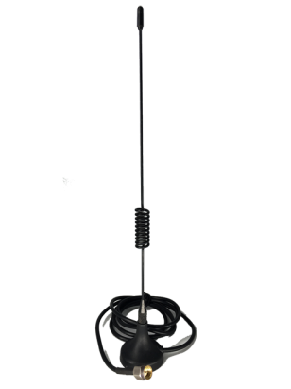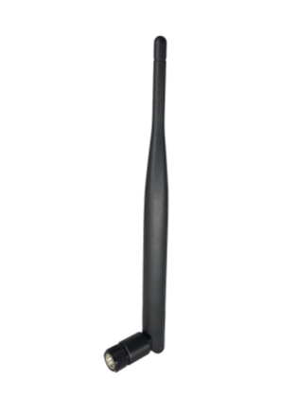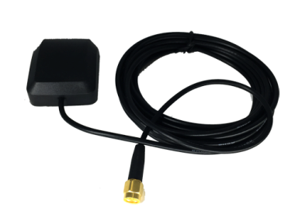
Cellular antenna (Standard) WiFi antenna (Standard) GPS antenna (Optional)

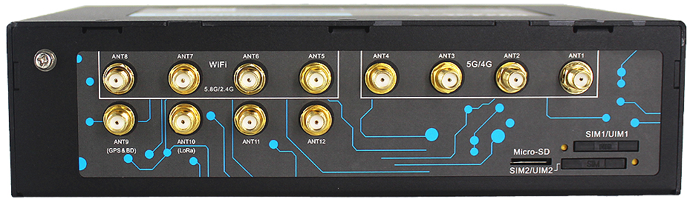
Antenna installation
Screw the SMA male pin of the cellular antenna to the female SMA interface of the edge computing gateway with sign “5G/4G” (some models are 2-6 antennas, namely "ANT1-ANT4", "ANT11, ANT12").
Screw the SMA female pin of the WiFi antenna to the male SMA interface of the edge computing gateway with sign “WiFi” (some models are 2-4 antennas, namely "ANT5-ANT8").
Screw the SMA male pin of the GPS antenna (optional) to the female SMA interface of the edge computing gateway with sign “GPS” (namely "ANT10).
Warning: The cellular antenna and the WiFi antenna cannot be connected wrongly. And the antennas must be screwed tightly, or the signal quality of antenna will be influenced!

Installation of SIM/UIM card:
SIM/UIM Card Installation
Firstly power off the edge computing gateway, and press the out button of the SIM/UIM card outlet with a needle object. Then the SIM/UIM card sheath will flick out at once. Put SIM/UIM card into the card sheath (Pay attention to put the side which has metal point outside), and insert card sheath back to the SIM/UIM card outlet.
Warning: Forbid to install SIM/UIM card when powered!

Installation of cable:
Edge computing gateway uses the industrial terminal interface. It is recommended to use 22-16 AWG cables for power supply and 28-18 AWG cables for communication

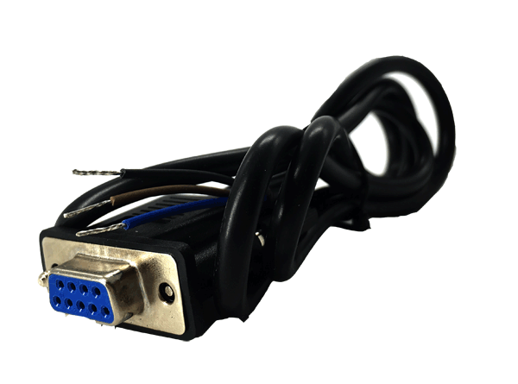  RS232 cable (standard) | 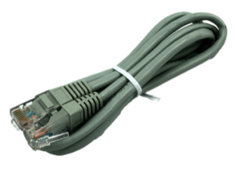  RJ45 network cable (standard)
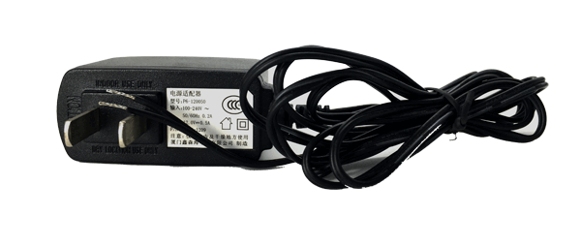  Power adapter (optional) | 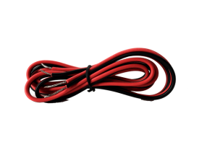  RS485 cable (optional)

RS232 cable:
The signal definition of the DB9F serial communication interface is as follows:
Color of wire | DB9 female
Blue(TX) | 2
Brown(RX) | 3
Black(GND) | 5

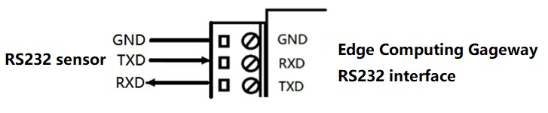

Debug cable:
Debug Serial port is the same serial port as RS232-0. The connection is refer to the figure above (RS232 cable).

Power adapter:
The definition of the 2pin industrial terminal (3.81mm pitch) is as follows:
Number | Definition | Remark
1 | V+ | Power positive
2 | V- | Power negative

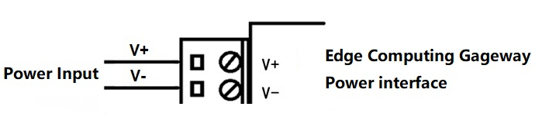

Network cable:
Insert one end of the network cable into the switch interface with sign “LAN1/LAN2/LAN3/LAN4”, and insert the other end into the Ethernet interface of user’s device. The signal connection of network direct cable is as follows:
RJ45-1 | 1 | 2 | 3 | 4 | 5 | 6 | 7 | 8
RJ45-2 | 1 | 2 | 3 | 4 | 5 | 6 | 7 | 8

RS485 cable:
The signal definition of the RS485 serial communication interface is as follows:
Color of wire | Definition
Red | RS485 A
Black | RS485 B

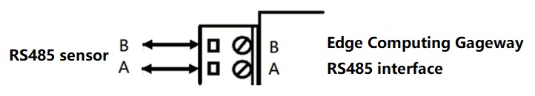

Digital input: (Dry contact, logic 0: connected, logic 1: disconnected)
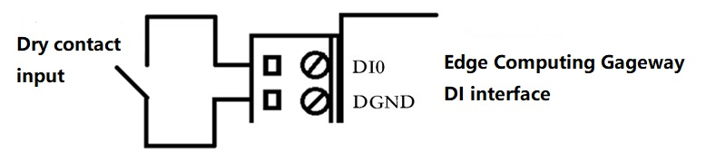

(Wet contact, logic 0: 0-3V DC, logic 1: 5-30V DC)
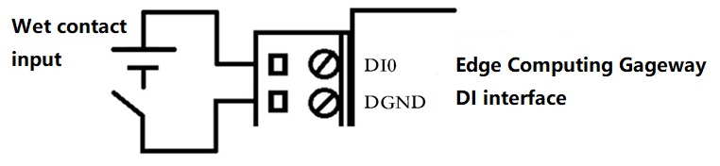

Relay: (Maximum switching voltage: 30V DC/250V AC, Maximum switching current: 5A, Maximum switching power: 150W)
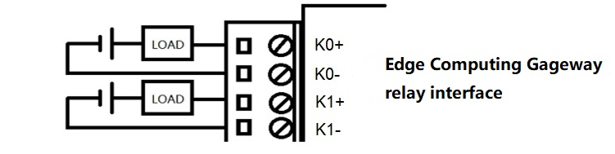

Controllable power output: (The output voltage is equal to the power supply voltage of the device. The default value is 12V DC. Single rated output current 1A, total rated output current 2A, built-in overcurrent protection, enhanced model)
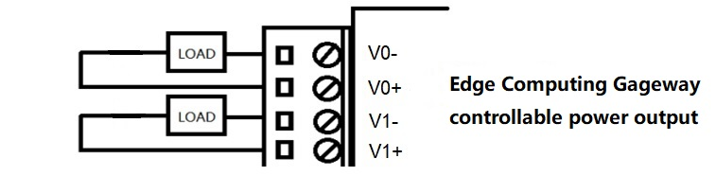

Analog input: (12-bit ADC, Input current range: 4-20mA, input voltage range: 0-5V)
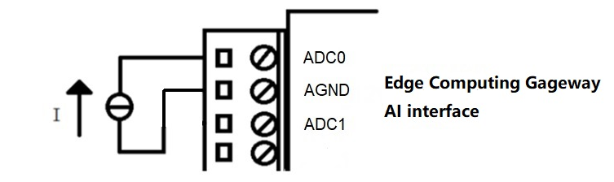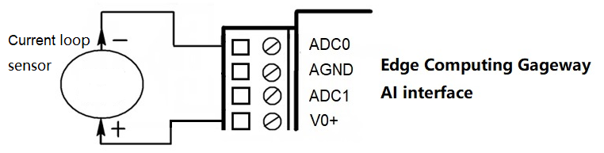
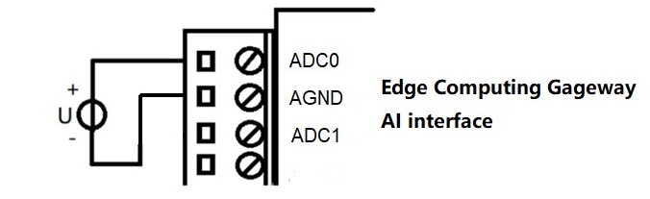

Udometer：
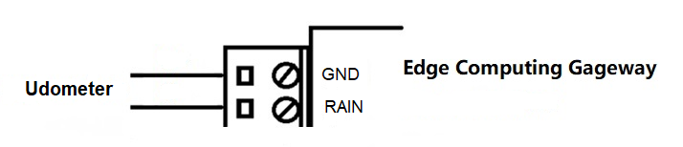

CAN Bus: (Meets ISO 11898)
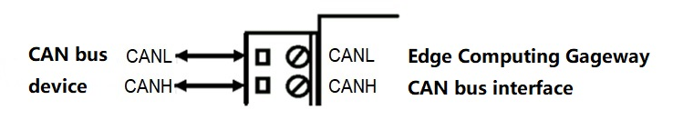

Power
Power Adapter (optional)
The power range of the edge computing gateway is DC 9~35V.
Warning: When we use other power, we should make sure that the power can supply power above 15W.
We recommend user to use the optional DC 12V/1.5A power.

LED
The edge computing gateway provides following LED lights: “PWR”, “RUN”, “SIM1”, “SIM2”, “Online”, “LAN1”, “LAN2”, “LAN3”, “LAN4”, “WAN”, “MOD1 Signal strength”, “MOD2 Signal strength”, “WiFi2.4”, “WiFi5.8”

LED | State | Description
MOD1/MOD2 Signal strength (Blue) | Off | The signal is terrible
MOD1/MOD2 Signal strength (Blue) | Slow blink | Signal strength is weak
MOD1/MOD2 Signal strength (Blue) | Fast blink | Signal strength is medium
MOD1/MOD2 Signal strength (Blue) | Always on | Signal strength is good
Power(Red) | On | Device is powered on
Power(Red) | Off | Device is powered off
RUN(Blue) | Blink | Device works normally
RUN(Blue) | On/Off | Device does not work
SIM1(Blue) | On | SIM1/UIM1 card is recognized
SIM1(Blue) | Off | SIM1/UIM1 card is not recognized
SIM2(Blue) | On | SIM2/UIM2 card is recognized
SIM2(Blue) | Off | SIM2/UIM2 card is not recognized
Online(Green) | On | Device has logged on network
Online(Green) | Off | Device hasn’t logged on network
LAN1(Yellow) | On/Blink | LAN1 is connected /Communicating
LAN1(Yellow) | Off | LAN1 is not connected
LAN2(Yellow) | On/Blink | LAN2 is connected /Communicating
LAN2(Yellow) | Off | LAN2 is not connected
LAN3(Yellow) | On/Blink | LAN3 is connected /Communicating
LAN3(Yellow) | Off | LAN3 is not connected
LAN4(Yellow) | On/Blink | LAN4 is connected /Communicating
LAN4(Yellow) | Off | LAN4 is not connected
WAN(Yellow) | On/Blink | WAN is connected /Communicating
WAN(Yellow) | Off | WAN is not connected
WiFi 2.4(Blue) | On | 2.4G WiFi is enable
WiFi 2.4(Blue) | Off | 2.4G WiFi is not enable
WiFi 5.8(Blue) | On | 5.8G WiFi is enable
WiFi 5.8(Blue) | Off | 5.8G WiFi is not enable

Reset Button Introduction
The edge computing gateway has a “Reset” button to restore it to its original factory default settings. When user press the “Reset” button for up to 8 seconds, the edge computing gateway will restore to its original factory default settings and restart automatically. (The auto-restart is as follows: the "RUN" LED turns off for about 10 seconds and then functions are normally)

Installation Introduction
The enclosure supports mounting lug and 35mm DIN rail.

Lightning protection Introduction
We suggest to take some lightning protection measures (such as installing lightning protection device) to improve the safety protection level of the edge computing gateway when it is connected to an outdoor sensor, such as an udometer, etc.

