AltRTU600L Industrial Cellular RTU User Manual
Support 5G/4G Industrial Data Acquisition instrument

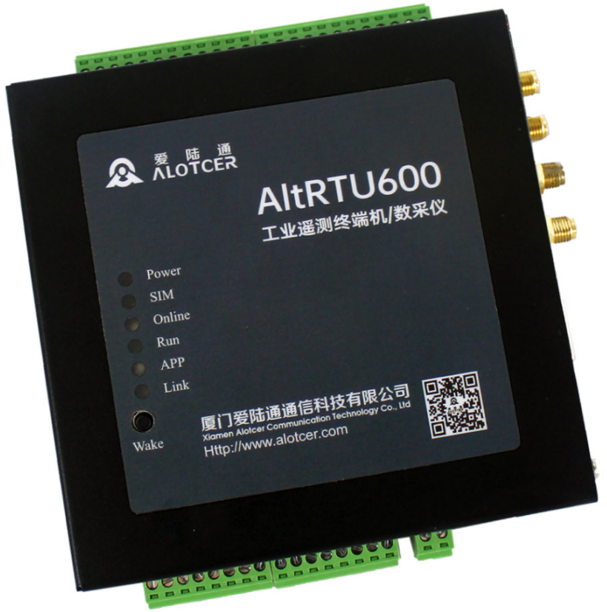


Xiamen Alotcer Communication Technology Co., Ltd.
Tel:+86-18106932752
Fax:+86 592-6195620
Web: https://www.alotceriot.com/
E-mail:anne@alotcer.com
Add: Room 502, No.146 Xinglinbei 2nd Road, Jimei District, Xiamen, China, 361022

Applicable Models:
Product Type | Model | Product Name
Standard | AltRTU600L-R | 5G industrial cellular RTU
Standard | AltRTU600L-L | 5G Redcap industrial cellular RTU
Standard | AltRTU600L-A | 4G industrial cellular RTU
Standard | AltRTU600L-F | 4G FDD industrial cellular RTU
Standard | AltRTU600L-Q | 4G FDD/TDD industrial cellular RTU
Standard | AltRTU600L-H | 4G Cat1 industrial cellular RTU
GPS | AltRTU600L-RP | GPS+5G industrial cellular RTU
GPS | AltRTU600L-LP | GPS+5G Redcap industrial cellular RTU
GPS | AltRTU600L-AP | GPS+4G industrial cellular RTU
GPS | AltRTU600L-FP | GPS+4G FDD industrial cellular RTU
GPS | AltRTU600L-QP | GPS+4G FDD/TDD industrial cellular RTU
GPS | AltRTU600L-HP | GPS+4G Cat1 industrial cellular RTU

Version
Version | Author | Check | Date | Description
V1.0 | Hewenfeng | Deron | 2023-10-12 | Initial

Contents

Version 3
Contents 4
Chapter 1 Brief Introduction 5
1.1 General 5
1.2 Product Feature 5
1.3 Block Diagram 7
1.4 Product SPEC 8
1.5 Ordering Information 10
Chapter 2 Installation Introduction 11
2.1 General 11
2.2 Packing List 11
2.3 User Interface Description 12
2.4 Installation and Cable Connection 14
2.4.1 Installation of antenna: 14
2.4.2 Installation of SIM/UIM card: 15
2.4.3 Installation of cable: 15
2.5 Power Supply 19
2.6 Indicator Lights Introduction 19
2.7 Wake Up Button Description 20
2.8 Installation Instruction 20
2.9 Lightning protection Introduction 20

Brief Introduction

General
AltRTU600L is an industrial cellular RTU developed based on 5G/4G LTE connectivity. It adopts high-powered industrial 32 bits CPU and industrial wireless module, and embedded real time operating system to realize comprehensive functions such as data acquisition, storage, control, alarm, remote transmission and remote management.
AltRTU600L supports RS232, RS485, Ethernet, Tipping bucket Rain gauge, Analog Input, Digital Input (dry and wet contacts), Digital Output, Relay Output and other interfaces. It supports internal flash and external expansion Micro-SD card to store data, and network communication through 5G or 4G, NB IoT, Lora, Ultra-short wave and other ways. It has powerful functions, stable performance, and supports low power consumption working mode.
AltRTU600L has been widely used in flood mitigation, hydrology, water resources, water pollution, environmental monitoring, meteorological monitoring, and so on.
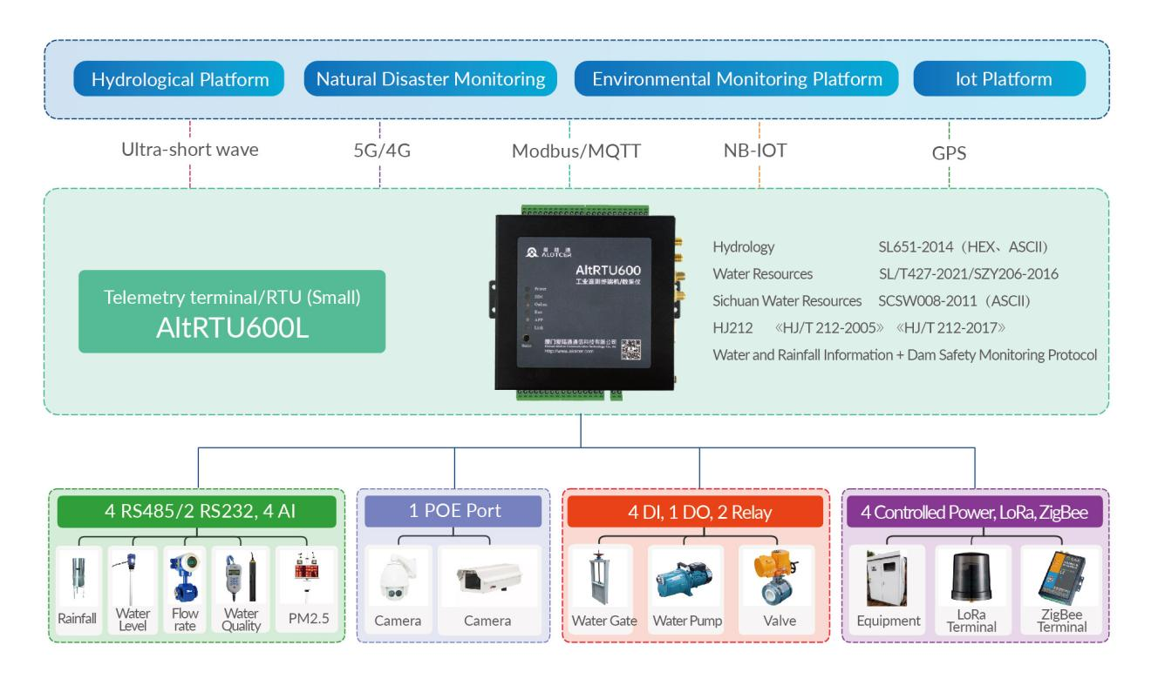
Application Topology

Product Feature
Items | Contents
Industrial Design | High-powered industrial cellular module
Industrial Design | High-powered industrial 32bits CPU
Industrial Design | Wide Operating Temperature(-35~+75ºC)
Industrial Design | Power range: DC 9~35V
High  Reliability | Support hardware and software WDT
High  Reliability | Support auto recovery mechanism, including online detect, auto redial when offline to make it always online
High  Reliability | Ethernet port: 1.5KV magnetic isolation protection
High  Reliability | RS232/RS485ports:15KV ESD protection
High  Reliability | SIM/UIM port: 15KV ESD protection
High  Reliability | Strong anti-interference ability, suitable for various complex electromagnetic environments
High  Reliability | Large data storage space(16MB), can store data more than 10 years
High  Reliability | Power port: reverse-voltage and overvoltage protection
High  Reliability | Antenna port: lightning protection(optional)
Standard  and Convenience | Support standard RS232/RS485 and Ethernet ports that can connect to serial and network devices directly
Standard  and Convenience | Multiple low-power working modes to use Convenient and flexible
Standard  and Convenience | Multiple indicator lights that can indicate various system states
Standard  and Convenience | Supports serial port upgrade, remote maintenance, and device log export
Major  Function | Trigger collection Rainfall data
Major  Function | Regularly collection Water Level, Rainfall , Water Quality, and other data
Major  Function | Regularly upload Rainfall, Water Level, Flow rate, Water Quality, and other data
Major  Function | Alarm trigger and upload Rainfall, Water Level, Flow rate, Water Quality, and other data
Major  Function | Local storage Rainfall, Water Level, Flow rate, Water Quality, and other data
Major  Function | Remote measurement current Rainfall, Water Level, Flow rate, Water Quality, and other data
Major  Function | Remote query local historical data
Major  Function | Local export historical data
Major  Function | Support upload battery voltage
Major  Function | Support capture image
Major  Function | Support local manual setting data
Major  Function | Backup data through 5G/4G network data communication and SMS
Major  Function | Support Communication Methods includes NB-IoT,Lora, Ultra-short wave,and so on
Major  Function | Built in temperature and humidity sensors
Major  Function | Support PoE(PSE)(optional)
Major  Function | Support GPS positioning (optional)
Protocol  (Customizable) | SLT 180-2015 Hydrological Automatic Measurement and Reporting System Equipment Telemetry Terminal
Protocol  (Customizable) | SLT 102-1995 Basic technical conditions of Hydrological Automatic Measurement and Reporting System Equipment
Protocol  (Customizable) | SL61-2003 Technical Specification for Hydrological Automatic Measurement and Reporting System
Protocol  (Customizable) | SZY203-2016 Technical requirements for water resource monitoring equipment
Protocol  (Customizable) | SZY205-2016 Quality inspection of water resource monitoring equipment
Protocol  (Customizable) | GB 3096-2008 Acoustic Environmental Quality Standards
Protocol  (Customizable) | GB/T 16706-1996 Environmental pollution source category code
Protocol  (Customizable) | GB/T 19582-2008 Industrial Automation Network Specification Based on Modbus Protocol
Protocol  (Customizable) | HJ/T 75-2007 Technical Specification for Continuous Monitoring of Smoke Emissions from Fixed Pollution Sources (Trial)
Protocol  (Customizable) | HJ/T 76-2007 Technical requirements and monitoring methods for continuous monitoring of flue gas emissions from fixed pollution sources (Trial)
Protocol  (Customizable) | HJ 524-2009 Air pollutant name code
Protocol  (Customizable) | Data transmission standard for online monitoring (monitoring) system of pollutants
Protocol  (Customizable) | HJ/T212-2005 Data transmission standard for online automatic monitoring (monitoring) system of pollution sources
Protocol  (Customizable) | HJ 212-2017 Data transmission standard for online monitoring (monitoring) system of pollutants
Protocol  (Customizable) | HJ 477-2009 Technical requirements for online automatic monitoring (monitoring) data acquisition and transmission equipment for pollution sources
Protocol  (Customizable) | Communication protocol for hydrological monitoring data
Protocol  (Customizable) | Water resource monitoring data transmission protocol

Block Diagram
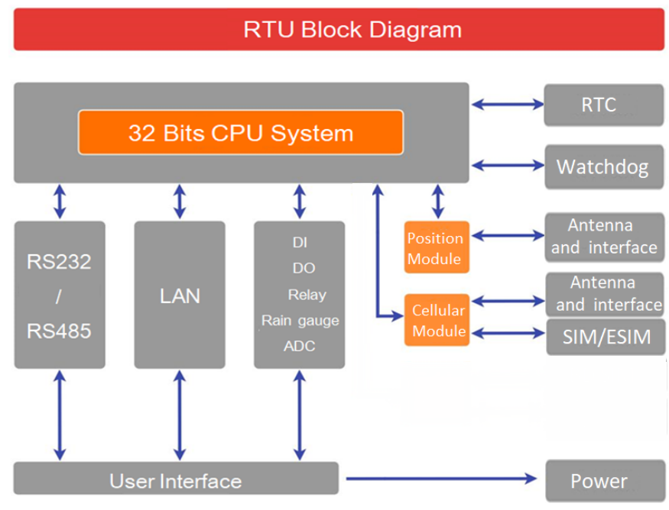

Product SPEC
Items |  | Contents
Hardware System | CPU | Industrial 32bits CPU
Hardware System | FLASH | 512KB
Hardware System | SDRAM | 256KB
Hardware System | Data Flash | 16MB
Hardware System | Micro-SD Card | Support External Micro-SD Card
Interface | Serial Ports | 4 RS232 and 4 RS485 (RS232-0 and RS485-0 cannot be used simultaneously, RS232-1 and RS485-1 cannot be used simultaneously), built-in 15KV ESD protection.  The serial port parameters are as follows:  Data bits: 5, 6, 7, 8  Stop bits: 1, 1.5 (optional), 2 bits  Verification: No verification, even verification, odd verification  Serial port speed: 300~230400bps, default 115200bps  Form: 3.5mm spacing industrial terminal
Interface | Debug Serial | 1 RS232 Debug serial port (common with RS485-3 ,switched through Debug switch). Form: standard DB9 female
Interface | Debug switch | Universal toggle switch
Interface | Ethernet | One 10/100M Ethernet port,Adaptive MDI/MDIX with built-in 1.5KV electromagnetic isolation protection. (PSE (optional), the equipment power supply voltage is required to meet 10.5~14VDC)
Interface | Antenna | Standard SMA female interface, 50 ohm
Interface | SIM/UIM | Standard drawer type user card interface，Support 1.8V/3V SIM/UIM card with built-in 15KV ESD protection
Interface | Micro-SD Card | Standard self-propelled Micro-SD card interface (Max 128GB)
Interface | Power | 1 main power supply, built-in power reverse protection and overcurrent and overvoltage protection,form: 2PIN 3.81MM pitch industrial terminal
Interface | Wake up button | Tact switch
Interface | Grounding terminal | M3 screw grounding protection terminal
Interface | User interface | 1 udometer interface
Interface | User interface | 4-channels analog input interface(12 bit ADC ,support 4-20mA or 0-5V, acquisition accuracy: 1-5V or 4-20mA accuracy within 0.5%, 0-1V accuracy within 5%)
Interface | User interface | 4-channels digital input interface (optical isolation)  Logic 0: Wet node 0-3VDC, or dry node connect  Logic 1: Wet node 5-30VDC, or dry node disconnect
Interface | User interface | 1-channels digital output interface (optical isolation, OC gate output)  Rated driving current: 50mA  Rated driving voltage: 35V
Interface | User interface | 2-channels relay output interface  Maximum switching voltage: 30VDC/250VAC  Maximum switching current: 5A  Maximum switching power: 150W/1200VA
Interface | User interface | 4-channels controllable output power supply (output voltage value is the same as the supply voltage, default 12VDC. Single channel rated output current 1A, 4-channels rated output current total 2A, built-in overcurrent protection
Interface | Indicator lights | Power, Online, SIM, Run,APP,LINK
Network parameters | Wireless network | 5G NR SA/NSA: n1/2/3/5/7/8/12/20/28/41/66/ 71/77/78/79  TDD-LTE: B38/39/40/41  FDD-LTE: B1/2/3/4/5/7/8/13/17/20/25/28  WCDMA: 850/900/1900/2100MHz  TD-SCDMA: 1880-1920/2010-2025MHz(A/F)  CDMA2000 1x/ EVDO Rev. A: 800/1900MHz  GSM/GPRS/EDGE: 850/900/1800/1900MHz  CDMA: 800/1900MHz
Network parameters | NB-IoT Parameters | Frequency band: B5: 850MHz/B8: 900MHz/B20: 800MHz  Theoretical bandwidth: 100bps~100Kbps  Transmission power: 23 ± 1dBm  Receiving sensitivity:<-129dBm
Network parameters | Lora Parameters | Frequency band:410MHz-441MHz,1000KHz step,recommended 433 ± 5MHz  Indoor/urban communication distance: 1KM  Outdoor/line of sight communication distance: 3KM  Transmission power: 100mW  Receiving sensitivity: ＜-140dBm
Installation mode | Fixed piece | Fixed with hanging ears on both sides
Installation mode | Rail | 35mm Din rail
Power Consumption | Power range | DC 9~35V (12V DC recommended)
Power Consumption | Communication | <100mA (@12VDC)  (only connected one RS485 sensor , and then communicates remotely with the data central for 100B/S.High power mode.)
Power Consumption | Collection | <10mA (@12VDC)  (only connected one RS485 sensor, RTU not online)
Power Consumption | Sleep(Static duty) | <2mA (@12VDC)
Power Consumption | Deep Sleep | < 40uA @ 12VDC
Physical | Dimensions | 116.2x114.2x33.1mm(Excluding accessories)
Physical | Shell | Metal shell, protection level IP30. Shell and system safety isolation, especially suitable for industrial control on-site applications
Physical | Weight | Approximately 460g
Environmental Limits | Operating Temperature | -35~+75ºC (-31~+167℉)
Environmental Limits | Storage Temperature | -40~+85ºC (-40~+185℉)
Environmental Limits | Operating Humidity | 95% (non-condensing)

Ordering Information
Model | Version
Model | Network Abbreviation | Function Extension
AltRTU600L | -R: 5G  -L: 5G Redcap  -A: 4G  -F: 4G FDD  -Q: 4G FDD/TDD  -H: 4G Cat1 | S: Dual SIM  P: GPS
Example | AltRTU600L-FP: 4G FDD industrial cellular RTU,support GPS.

Installation Introduction

General
The RTU must be installed correctly to achieve the designed function. It is recommended to install and debug the equipment under the guidance of qualified engineers recognized by our company.
Warning:
Forbid to install when powered!
Forbid to disassemble the device without permission.

Packing List
Please take good care of the packaging materials when unpacking the equipment without permission, so that they can be used for future transportation. The list is as follows:
Name | Quantity | Remark
AltRTU600L Host | 1 | standard
Cellular antenna | 1-3 | standard
SIM card holder | 1 | standard
RS232 cable | 1 | standard
Certification card | 1 | standard
Power adapter | 1 | optional
Debug serial cable | 1 | optional
Micro-SD card | 1 | optional
GPS antenna | 1 | optional
RS485 cable | 1 | optional
RJ45 network cable | 1 | optional

User Interface Description
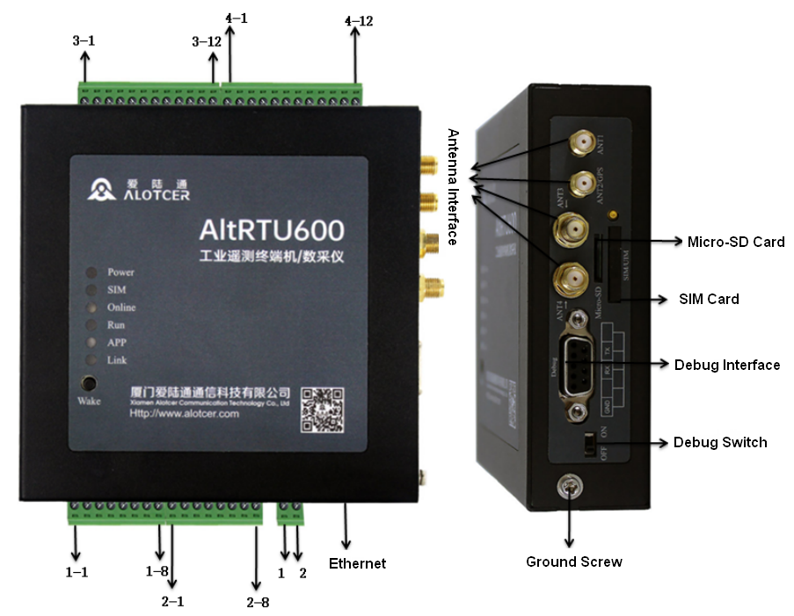
Interface definition:
Number | Function | Name | Default | Remark
1-1 | ADC Input | AI0 | Channel 0 analog input | 12 bit ADC (support 4-20mA or 0-5V, acquisition accuracy: 1-5V or 4-20mA accuracy within 0.5%, 0-1V accuracy within 5%)  Output voltage is equal to the power supply voltage (default 12V) ,Single rated output current 1A
1-2 | ADC Input | V0+ | Channel 0 controllable power output positive
1-3 | ADC Input | AGND | Analog GND
1-4 | ADC Input | AI1 | Channel 1 analog input
1-5 | ADC Input | AI2 | Channel 2 analog input
1-6 | ADC Input | V1+ | Channel 1 controllable power output positive
1-7 | ADC Input | AGND | Analog GND
1-8 | ADC Input | AI3 | Channel 3 analog input
2-1 | Digital input | DI0 | Channel 0 digital input | Optical isolation  Logic 0: wet contact 0-3V DC, or dry contact is connected  Logic 1: wet contact 5-30V DC, or dry contact is disconnected
2-2 | Digital input | DGND | Digital GND
2-3 | Digital input | DI1 | Channel 1 digital input
2-4 | Digital input | DI2 | Channel 2 digital input
2-5 | Digital input | DGND | Digital GND
2-6 | Digital input | DI3 | Channel 3 digital input
2-7 | Rainfall | GND | Udometer GND | Udometer interface
2-8 | Rainfall | Rain | Udometer input | Udometer interface
3-1 | 232-0 | TX0 | Channel 0 RS232 transmit (RTU transmit) | RS232-0 and RS485-0 cannot be used at the same time
3-2 | 232-0 | RX0 | Channel 0 RS232 receiver (RTU receiver) | RS232-0 and RS485-0 cannot be used at the same time
3-3 | 232-0 | GND | Channel 0 RS232 GND | RS232-0 and RS485-0 cannot be used at the same time
3-4 | 485-0 | A0 | Channel 0 RS485 A | RS232-0 and RS485-0 cannot be used at the same time
3-5 | 485-0 | B0 | Channel 0 RS485 B | RS232-0 and RS485-0 cannot be used at the same time
3-6 | Vout-2 | V2+ | Channel 2 controllable power output positive | Output voltage is equal to the power supply voltage (default 12V) ,Single rated output current 1A
3-7 | Vout-2 | V2- | Channel 2 controllable power output negative
3-8 | 232-1 | TX1 | Channel 1 RS232 transmit (RTU transmit) | RS232-1 and RS485-1 cannot be used at the same time
3-9 | 232-1 | RX1 | Channel 1 RS232 receiver (RTU receiver) | RS232-1 and RS485-1 cannot be used at the same time
3-10 | 232-1 | GND | Channel 1 RS232 GND | RS232-1 and RS485-1 cannot be used at the same time
3-11 | 485-1 | A1 | Channel 1 RS485 A | RS232-1 and RS485-1 cannot be used at the same time
3-12 | 485-1 | B1 | Channel 1 RS485 B | RS232-1 and RS485-1 cannot be used at the same time
4-1 | 485-2 | A2 | Channel 2 RS485 A | Output voltage is equal to the power supply voltage (default 12V) ,Single rated output current 1A
4-2 | 485-2 | B2 | Channel 2 RS485 B
4-3 | Vout-3 | V3+ | Channel 3 controllable power output positive | Output voltage is equal to the power supply voltage (default 12V) ,Single rated output current 1A
4-4 | Vout-3 | V3- | Channel 3 controllable power output negative
4-5 | 485-3 | A3 | Channel 3 RS485 A | RS485-3 and Debug Serial cannot be used at the same time through Debug toggle switch
4-6 | 485-3 | B3 | Channel 3 RS485 B
4-7 | Relay Output | K0+ | Channel 0 relay positive | Maximum switching voltage:  30V DC/250V AC  Maximum switching current: 5A  Maximum switching power: 150W/1200VA
4-8 | Relay Output | K0- | Channel 0 relay negative
4-9 | Relay Output | K1+ | Channel 1 relay positive
4-10 | Relay Output | K1- | Channel 1 relay negative
4-11 | Digital Output | DO | Digital output | Optical isolation, OC gate output  Rated driving current: 50mA  Rated driving voltage: 35V
4-12 | Digital Output | DOGND | Digital output GND

Installation and Cable Connection
Dimension (The fixing piece is detachable): (Unit: mm)
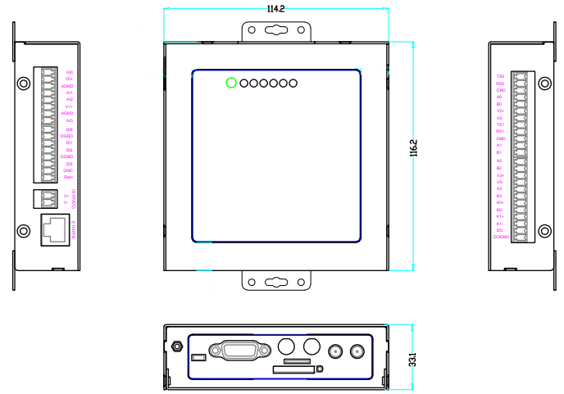
Installation of antenna:

Installation of antenna:
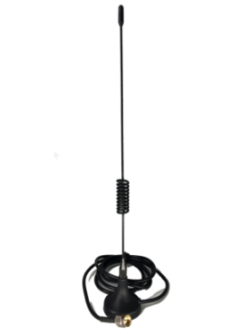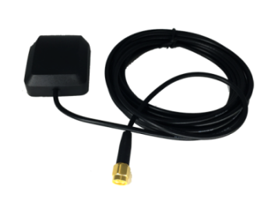
Cellular antenna (Standard) GPS /Beidou antenna (Optional)
The Cellular antenna interface is an SMA female ,labeled "ANT" (5G models have two antennas, namely "ANT1" and "ANT2").Screw the SMA male head of the cellular antenna to the antenna interface, and make sure to screw it tightly so as not to affect the signal quality.
The GPS antenna is SMA female, labeled "GPS/BD". Screw the SMA male of the matching GPS antenna onto the antenna interface ,and make sure to screw it tightly so as not to affect the signal quality.

Installation of SIM/UIM card:
Firstly power off RTU, and press the out button of the SIM/UIM card outlet with a needle object. Then the SIM/UIM card sheath will flick out at once. Put SIM/UIM card into the card sheath (Pay attention to put the side which has metal point outside), and insert card sheath back to the SIM/UIM card outlet.

Installation of cable:
RTU uses the industrial terminal interface. It is recommended to use 22-16 AWG cables for power supply and 28-18 AWG cables for communication.
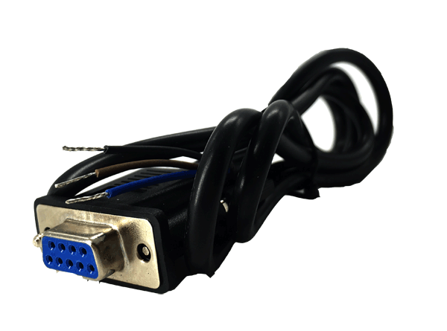  RS232 cable (standard) | 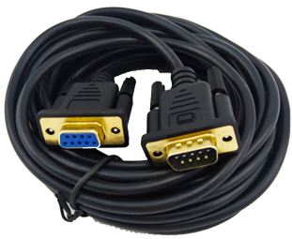  Debug serial cable (optional）
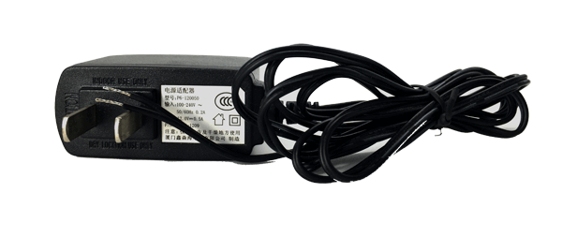  Power adapter (optional) | 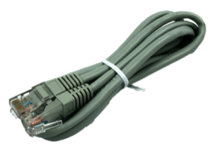  RJ45 network cable (optional)
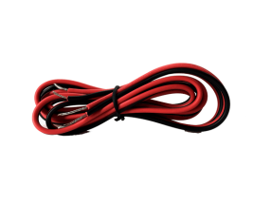
RS485 cable (optional)

RS232 cable:
The signal definition of the DB9F serial communication interface is as follows:
Color of wire | DB9 female
Blue(TX) | 2
Brown(RX) | 3
Black(GND) | 5

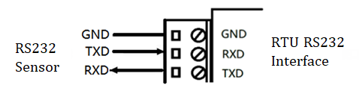
Debug Serial Cable：
It adopts standard DB9 female, and the interface definition is as follows:
DB9 female | Definition | Remark
2 | TXD | RTU data Transmit
3 | RXD | RTU data Receive
5 | RGND | RS232 GND
Debug serial port and RS485-3 multiplex the same serial port, the debug toggle switch needs to be turned to the ON position for Debug serial to function properly.
Power adapter:
The definition of the 2pin industrial terminal (3.81mm pitch) is as follows:

Number | Definition | Remark
1 | V+ | Main Power positive
2 | V- | Main Power negative
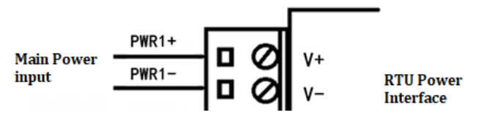
Network cable:
Insert one end of the network cable direct connection into RTU Ethernet interface ,and insert the other end into the Ethernet interface of user’s device. The signal connection of network direct cable is as follows:
RJ45-1 | 1 | 2 | 3 | 4 | 5 | 6 | 7 | 8
RJ45-2 | 1 | 2 | 3 | 4 | 5 | 6 | 7 | 8

RS485 cable:
The signal definition of the RS485 serial communication interface is as follows:
Color of wire | Definition
Red | RS485 A
Black | RS485 B

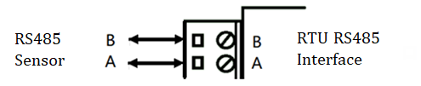

Digital input:
Dry contact, logic 0: connected, logic 1: disconnected

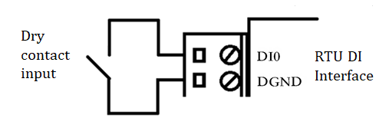
Wet contact, logic 0: 0-3V DC, logic 1: 5-30V DC)
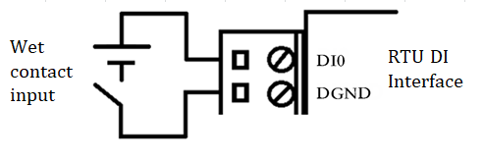
Digital output wiring: optical isolation, OC gate output, 50mA rated driving current, 35V rate driving voltage
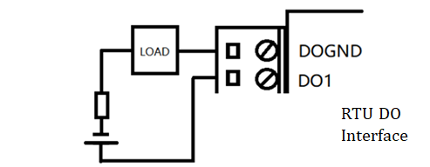
Relay: (Maximum switching voltage: 30V DC/250V AC, Maximum switching current: 5A, Maximum switching power: 150W/1200VA)
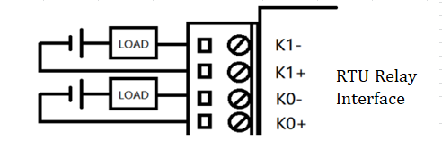

Analog input: (12-bit ADC, Input current range: 4-20mA, input voltage range: 0-5V)
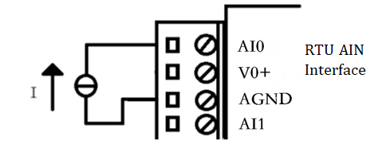
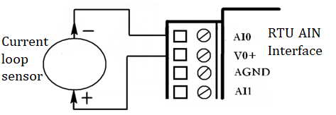
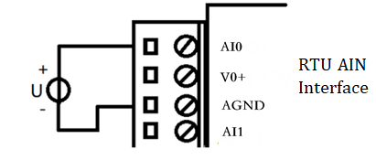

Udometer:

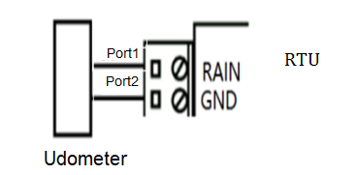

Controllable power output: (The output voltage is equal to the power supply voltage. The default value is 12V . Single rated output current 1A, total rated output current 2A, built-in overcurrent protection)
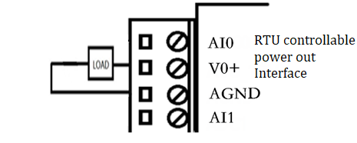

Power Supply
Power Adapter (optional)
The power range of the edge computing gateway is DC 9~35V,and the supply must ensure the stability of the power supply (ripple less than 300mV, and ensure the instantaneous voltage does not exceed 35V), and ensure the power supply is greater than 9W.
Warning: When we use other power supply, we should make sure that the rated power is greater than 9W.
We recommend user to use the optional DC 12V/1A power.

Indicator Lights Introduction
Indicator status description:
LED | Status | Description
Power  (Red) | OFF | Device is powered off or in sleep(static duty)/deep-sleep mode
Power  (Red) | ON | Device is powered on
SIM  (Blue) | OFF | SIM/UIM card not recognized
SIM  (Blue) | ON | SIM/UIM card recognized
Online  (Green) | OFF | Device is not online
Online  (Green) | ON | Device is online
RUN  (Yellow) | OFF | Device does not work or in deep-sleep mode
RUN  (Yellow) | Blink | Device works normally
RUN  (Yellow) | ON | Device does not work
APP  (Reserved) | OFF | TBD
APP  (Reserved) | ON | TBD
LINK  (Reserved) | OFF | TBD
LINK  (Reserved) | ON | TBD

Wake Up Button Description
RTU has a tact switch ("WAKE"). After enter sleep(static duty) state, press the wake-up button once can wake the device up. In addition, under normal working conditions:
Button operation | function | Remark
Press once | Data collection | based on user configuration
Press 2 to 3 seconds | Data collection and upload | based on user configuration
Press more than 5 seconds | Enter sleep(static duty) mode | Working current< 2mA@12VDC

Installation Instruction
The enclosure supports mounting lug and 35mm DIN rail.

Lightning protection Introduction
When the RTU device is connected to an outdoor sensor (such as a rain gauge, water level meter, etc.), it is recommended to take appropriate lightning protection measures (such as installing a lightning arrester, etc.) to improve the safety protection level of the equipment.
If you have any questions about the use of the lightning arrester, please consult the technical support engineer of Alotcer!

